1.

class ThreadLifeCycle extends Thread {

public void run() {
System.out.println("Thread is in RUNNING state.");

try {
System.out.println("Thread is going to SLEEP.");
Thread.sleep(1000);

System.out.println("Thread is RUNNING again.");
} catch (InterruptedException e) {
System.out.println(e);
}

System.out.println("Thread execution completed.");
}

public static void main(String[] args) throws InterruptedException {

ThreadLifeCycle t = new ThreadLifeCycle();

// NEW state
System.out.println("1. Thread State: " + t.getState());

// Runnable state
t.start();
System.out.println("2. Thread State after start(): " + t.getState());

// Main thread waits for child thread
t.join();

// Terminated state
System.out.println("3. Thread State after completion: " + t.getState());

System.out.println("Thread has TERMINATED.");
}
}

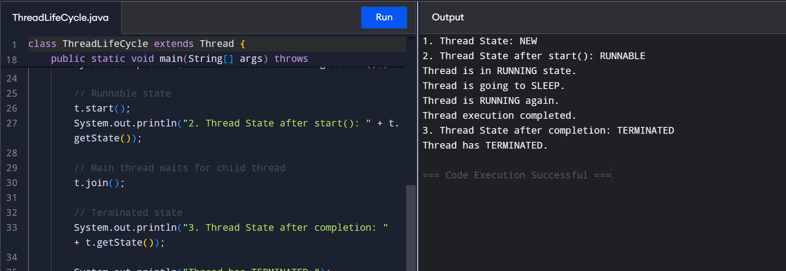

2. Thread Priorities

class PriorityThread extends Thread {

PriorityThread(String name) {
super(name);
}

public void run() {
for (int i = 1; i <= 5; i++) {
System.out.println(
"Thread Name: " + getName() +
" | Priority: " + getPriority() +
" | Count: " + i
);
}
}

public static void main(String[] args) {

PriorityThread high = new PriorityThread("High Priority");
PriorityThread medium = new PriorityThread("Medium Priority");
PriorityThread low = new PriorityThread("Low Priority");

high.setPriority(Thread.MAX_PRIORITY); // 10
medium.setPriority(Thread.NORM_PRIORITY); // 5
low.setPriority(Thread.MIN_PRIORITY); // 1

high.start();
medium.start();
low.start();
}
}
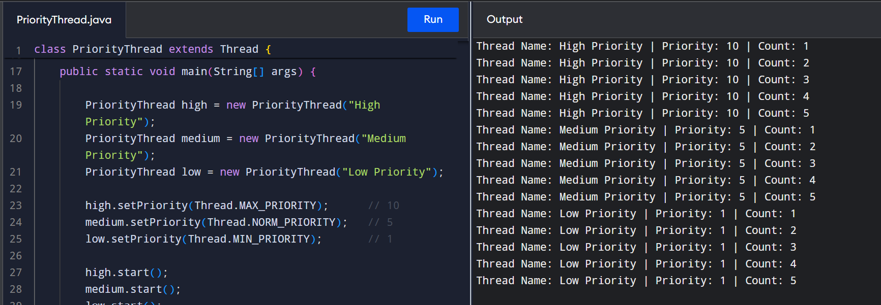

3. Synchronized Method

class BankAccount {

private int balance = 1000;

synchronized void deposit(int amount) {
System.out.println(
Thread.currentThread().getName() +
" depositing: " + amount
);

balance += amount;

System.out.println("Balance after deposit: " + balance);
}

synchronized void withdraw(int amount) {
System.out.println(
Thread.currentThread().getName() +
" withdrawing: " + amount
);

if (balance >= amount) {
balance -= amount;
System.out.println("Balance after withdrawal: " + balance);
} else {
System.out.println("Insufficient balance.");
}
}

int getBalance() {
return balance;
}
}

public class SynchronizedMethodDemo {

public static void main(String[] args) throws InterruptedException {

BankAccount account = new BankAccount();

Thread t1 = new Thread(() -> {
account.deposit(500);
}, "Thread-1");

Thread t2 = new Thread(() -> {
account.withdraw(300);
}, "Thread-2");

Thread t3 = new Thread(() -> {
account.withdraw(200);
}, "Thread-3");

t1.start();
t2.start();
t3.start();

t1.join();
t2.join();
t3.join();

System.out.println("Final Account Balance: " + account.getBalance());
}
}
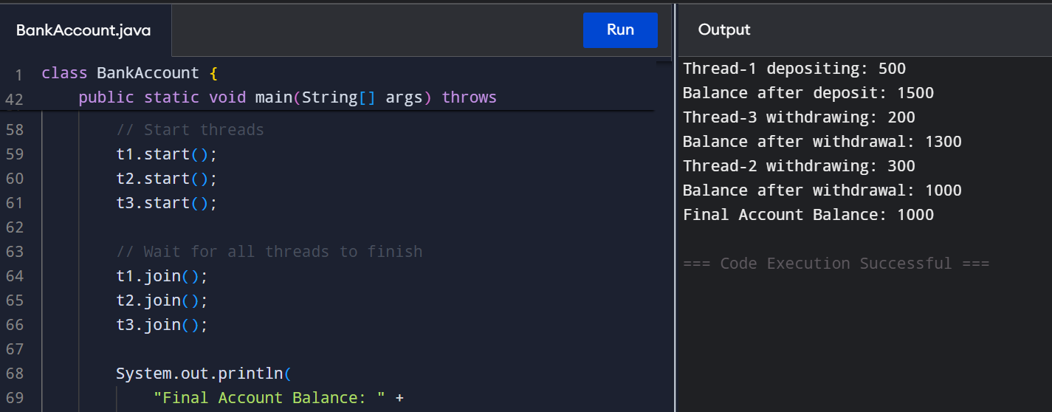

Q4. Synchronized Block
class TicketBooking {

int tickets = 5;

void bookTicket(int numberOfTickets) {

// Synchronized block
synchronized (this) {

System.out.println(
Thread.currentThread().getName()
+ " wants to book "
+ numberOfTickets
+ " ticket(s)."
);

if (tickets >= numberOfTickets) {

System.out.println(
Thread.currentThread().getName()
+ " is booking tickets..."
);

try {
Thread.sleep(500);
} catch (InterruptedException e) {
System.out.println(e);
}

tickets = tickets - numberOfTickets;

System.out.println(
Thread.currentThread().getName()
+ " booking successful."
);

System.out.println(
"Remaining tickets: " + tickets
);

} else {

System.out.println(
Thread.currentThread().getName()
+ " booking failed."
);

System.out.println(
"Not enough tickets available."
);
}
}
}

public static void main(String[] args)
throws InterruptedException {

TicketBooking booking = new TicketBooking();

Thread t1 = new Thread(() -> {
booking.bookTicket(2);
}, "Customer-1");

Thread t2 = new Thread(() -> {
booking.bookTicket(1);
}, "Customer-2");

Thread t3 = new Thread(() -> {
booking.bookTicket(2);
}, "Customer-3");

// Start threads
t1.start();
t2.start();
t3.start();

// Wait for all threads
t1.join();
t2.join();
t3.join();

System.out.println(
"All booking operations completed."
);

System.out.println(
"Final Remaining Tickets: "
+ booking.tickets
);
}
}
